1)Configure Classic Load balancer.
Step 1 — Launch EC2 Instances
- Go to AWS Console
- Open EC2
- Click Launch Instance
- Create 2 Instances
Example
- Instance Name → Web-Server-1
- Instance Name → Web-Server-2
- AMI → Amazon Linux
- Instance Type → t2.micro
- Security Group → Allow
  - HTTP (80)
  - SSH (22)
Launch both.
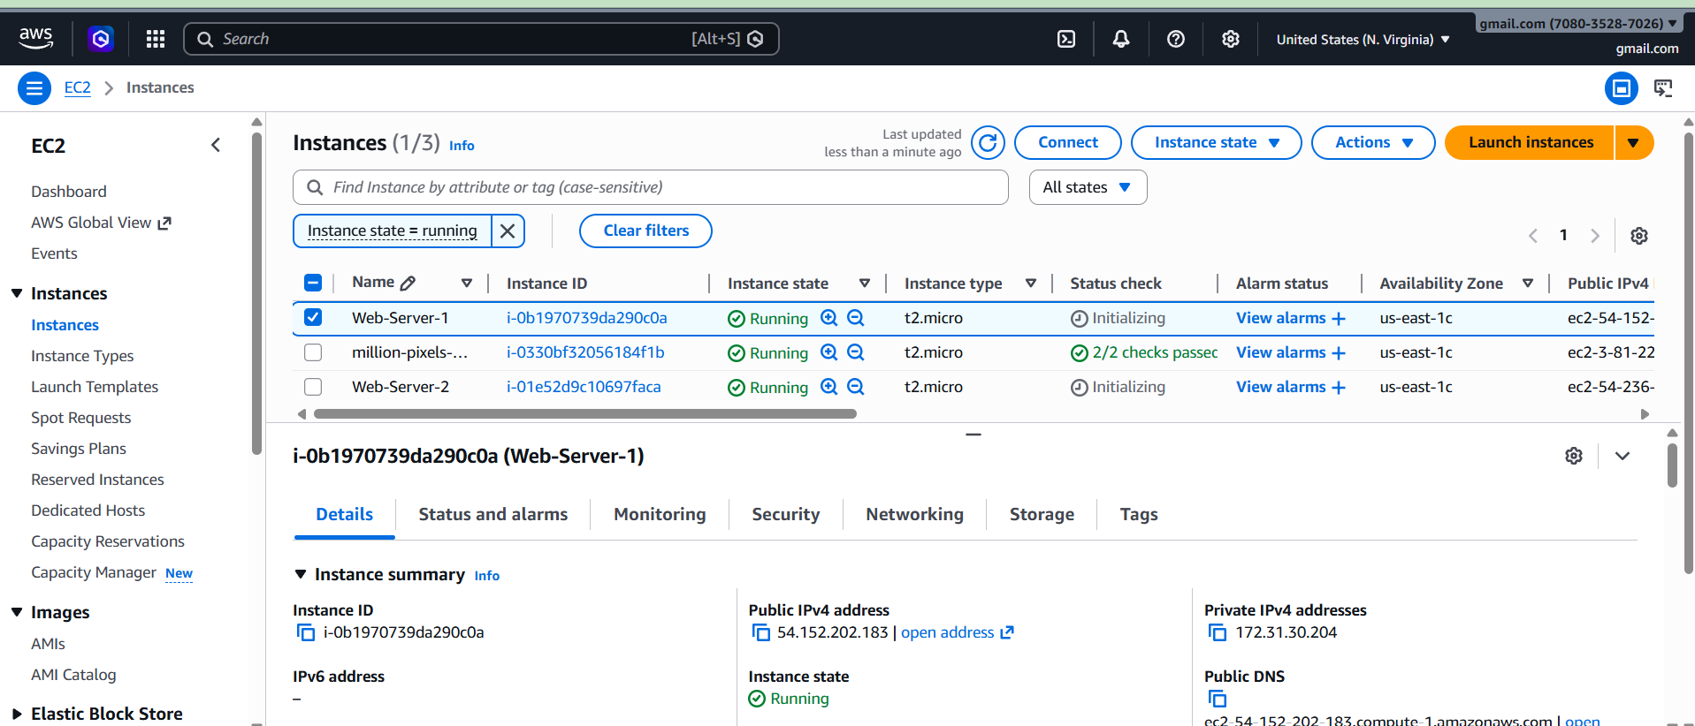

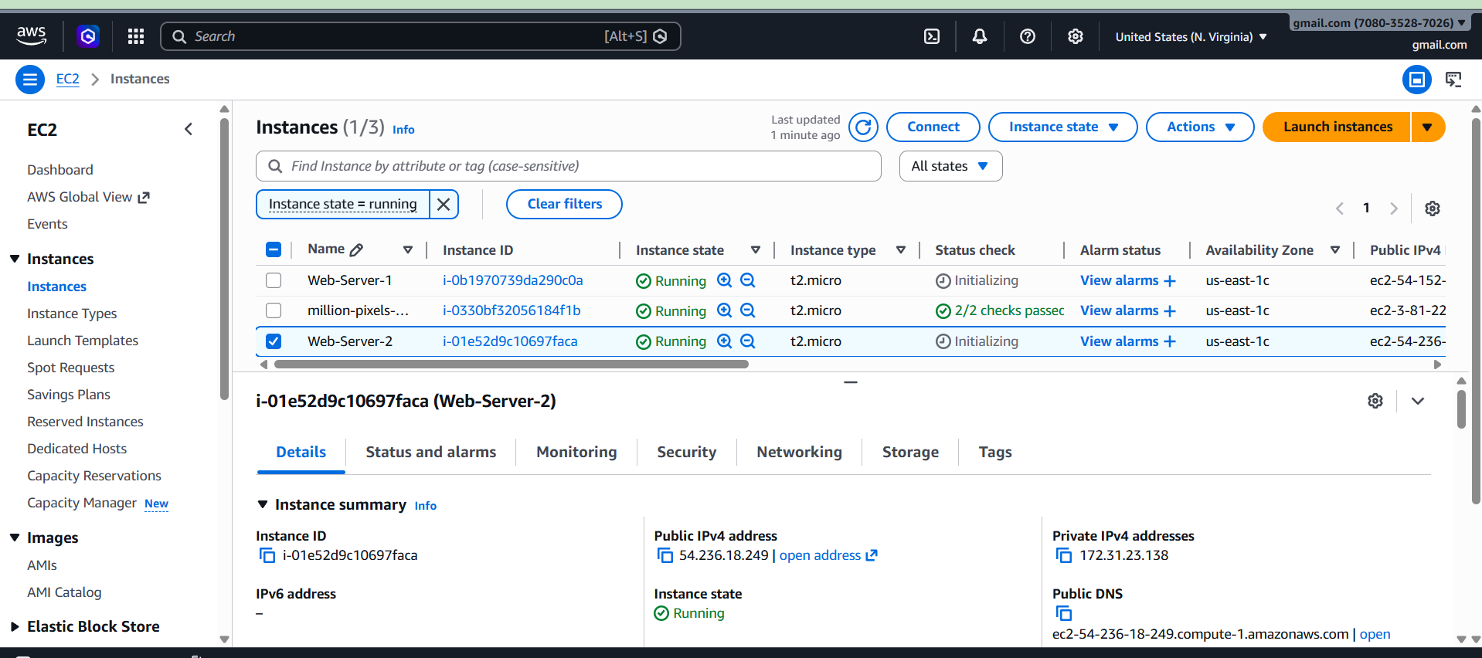

Step 2 — Install Web Server
SSH into both instances.
sudo yum update -y
sudo yum install httpd -y
sudo systemctl start httpd
sudo systemctl enable httpd

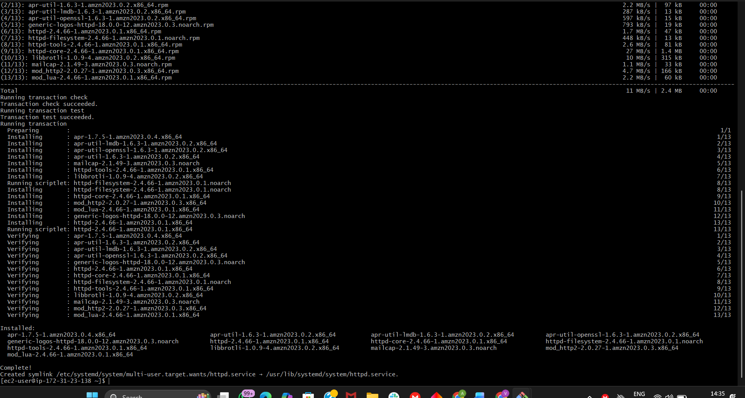

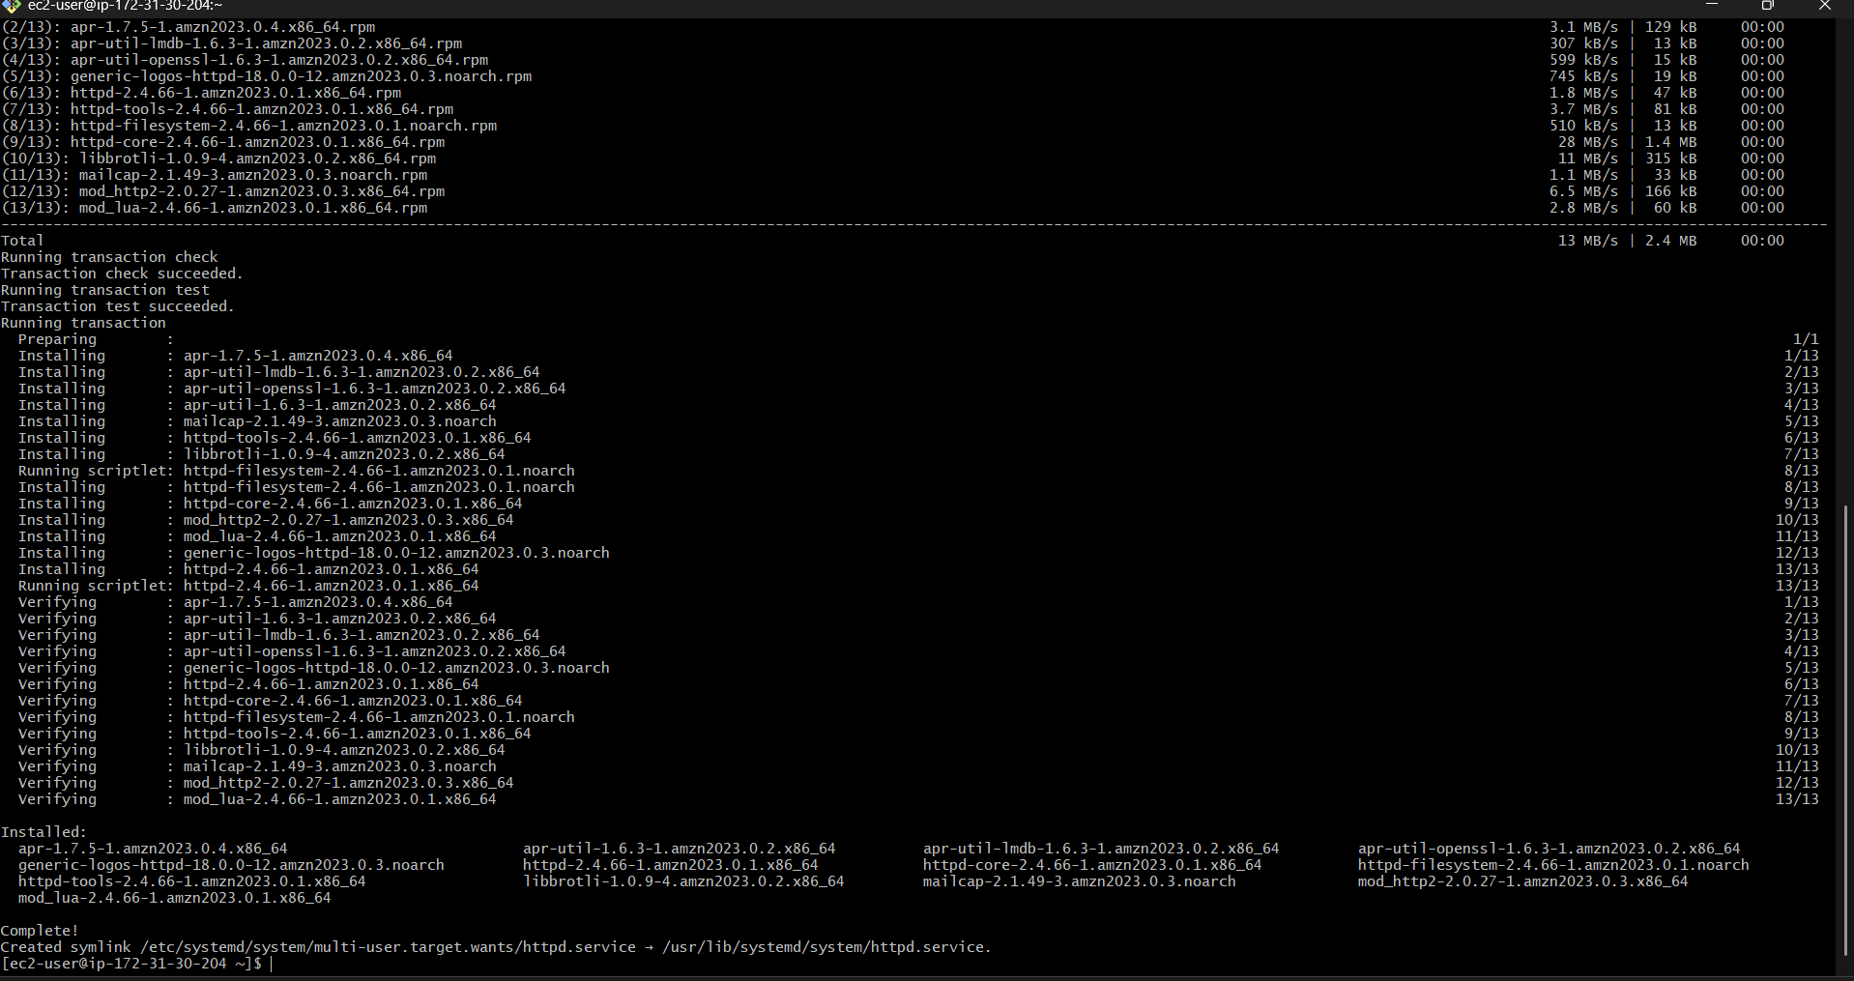
Create different pages to test load balancing.
Server 1
echo "Server 1" | sudo tee /var/www/html/index.html
Server 2
echo "Server 2" | sudo tee /var/www/html/index.html

Step 3 — Create Classic Load Balancer
Go to:
EC2 → Load Balancers → Create Load Balancer
Select
Classic Load Balancer
Configure
Name
CLB-Demo
Scheme
Internet Facing
Listener
HTTP
Port 80

Step 4 — Select VPC & Subnets
Choose
Default VPC
Select 2 Availability Zones
Example
us-east-1a
us-east-1b

Step 5 — Security Group
Create or select security group.
Allow
HTTP 80

Step 6 — Configure Health Check
Example
Ping Protocol : HTTP
Ping Port : 80
Ping Path : /

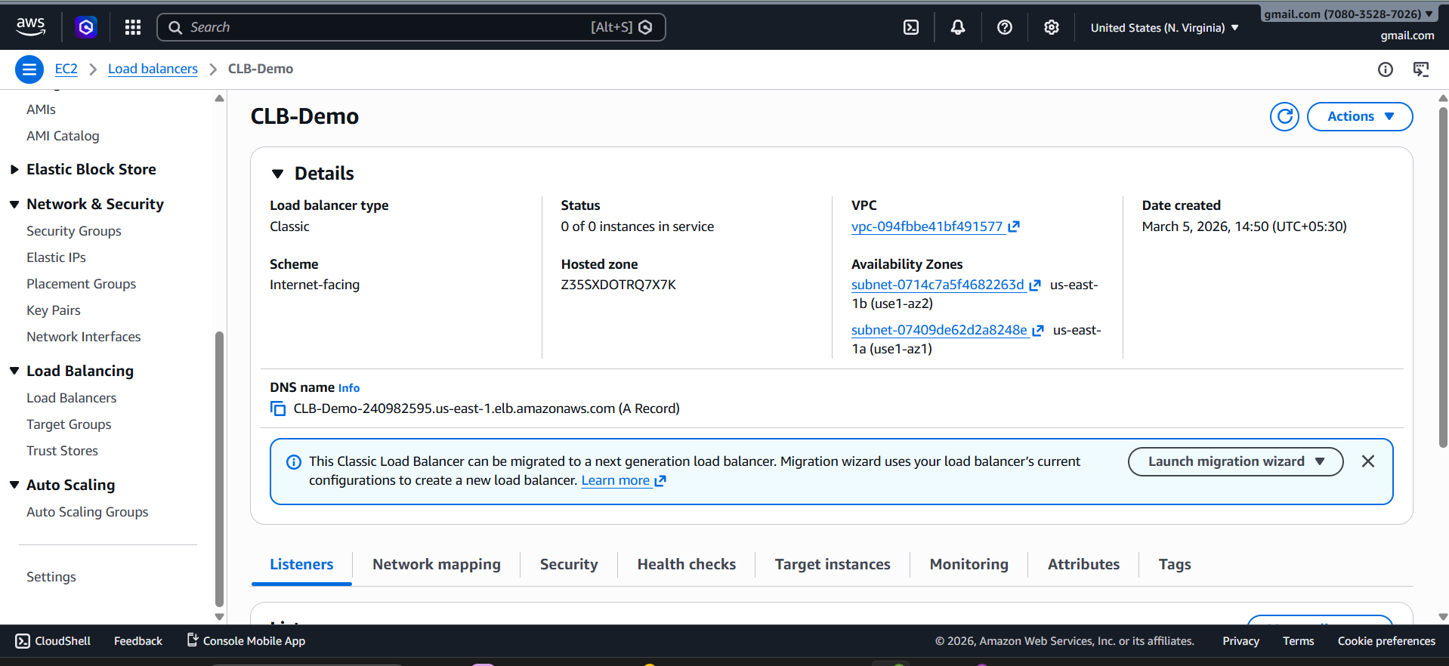

Step 7 — Register Instances
Select
Web-Server-1
Web-Server-2
Add to Load Balancer.
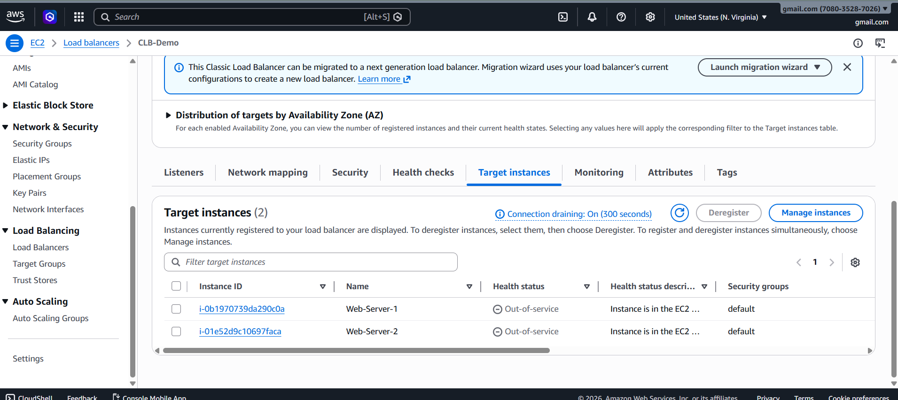

Step 8 — Test Load Balancer
Copy DNS name
Example
CLB-Demo-123456.us-east-1.elb.amazonaws.com
Open browser.
Refresh multiple times.
You will see
Server 1
Server 2
Server 1
Server 2
Load balancing working




2)Configure Application Load Balancer (ALB)
Step 1 — Create Target Group
Go to
EC2 → Target Groups
Create
Type
Instances
Name
TG-Web
Protocol
HTTP
Port
80
Register
Web-Server-1
Web-Server-2
Create.

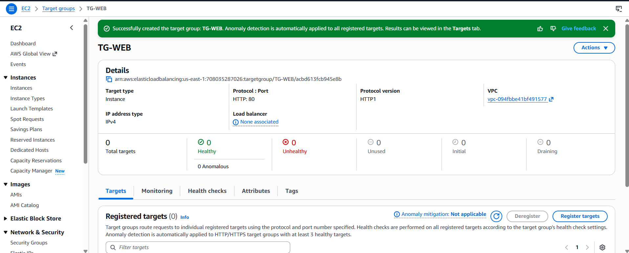

Step 2 — Create Application Load Balancer
Go to
EC2 → Load Balancers → Create
Select
Application Load Balancer
Configure
Name
ALB-Web
Scheme
Internet Facing
IP
IPv4

Step 3 — Select Network
Choose
Default VPC
2 Subnets
Example
us-east-1a
us-east-1b

Step 4 — Security Group
Allow
HTTP 80
HTTPS 443

Step 5 — Listener
HTTP : 80
Forward to Target Group
Select
TG-Web
Create.

Step 6 — Test
Copy ALB DNS
Example
ALB-645318146.us-east-1.elb.amazonaws.com
Open browser.
Refresh → traffic will rotate between servers.

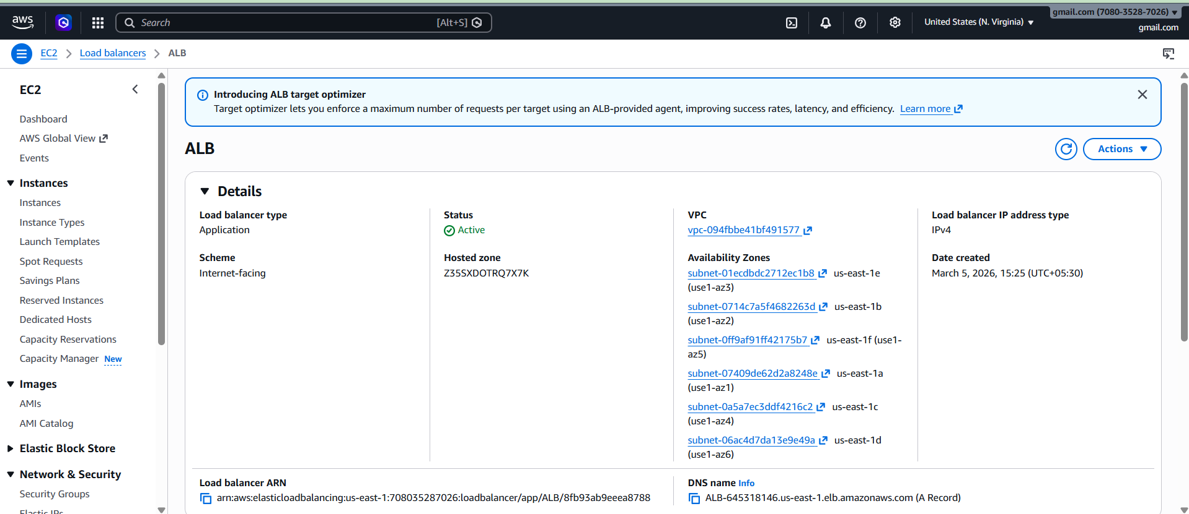

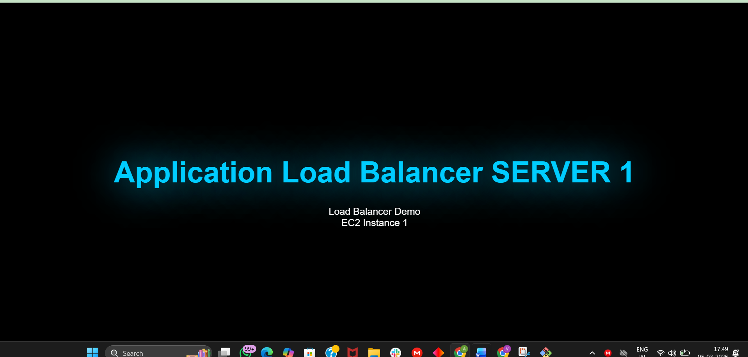


3) Configure Network Load Balancer (NLB)
Go to
EC2 → Load Balancer → Create
Select
Network Load Balancer
Configuration
Name :
NLB-Web
Scheme
Internet Facing
Listener
TCP : 80

Select VPC
Choose
Default VPC
2 Subnets

Create Target Group
Type
Instance
Protocol
TCP
Port
80
Register
Web-Server-1
Web-Server-2
Create.

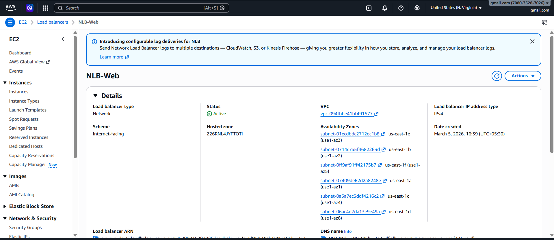

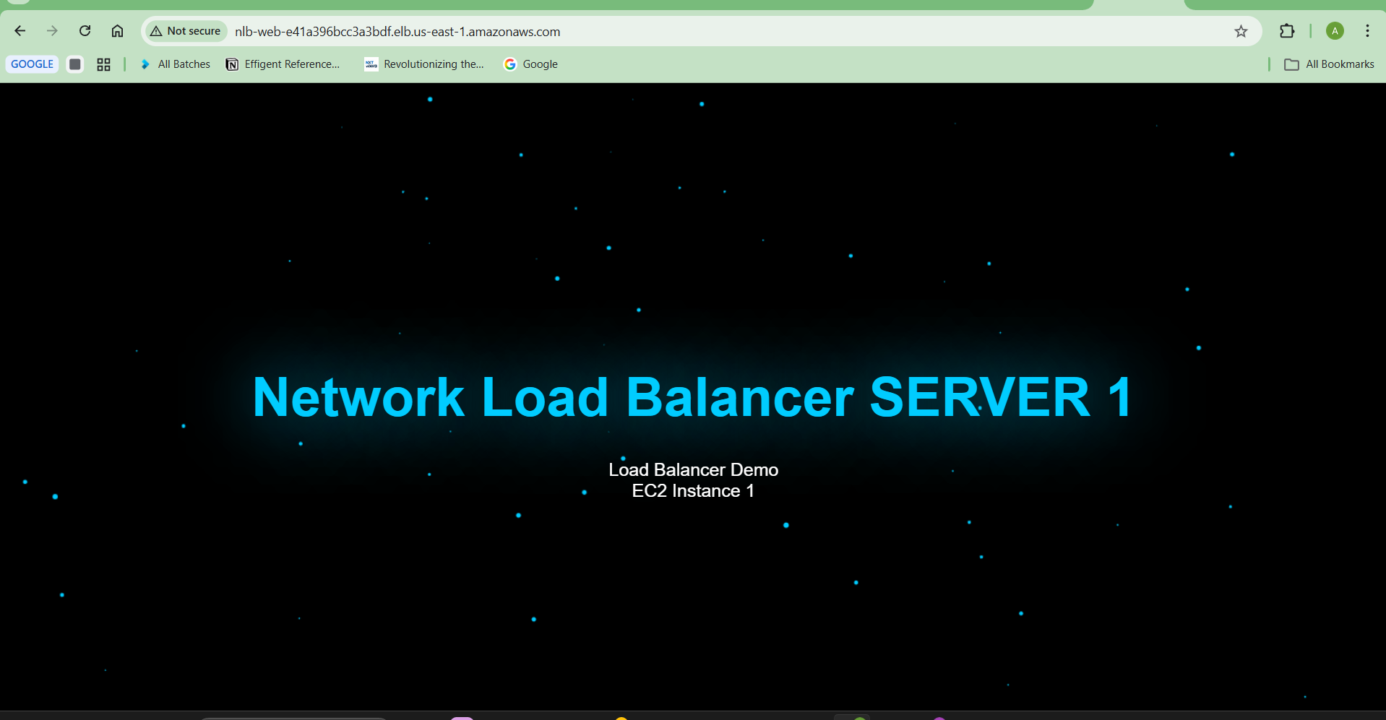
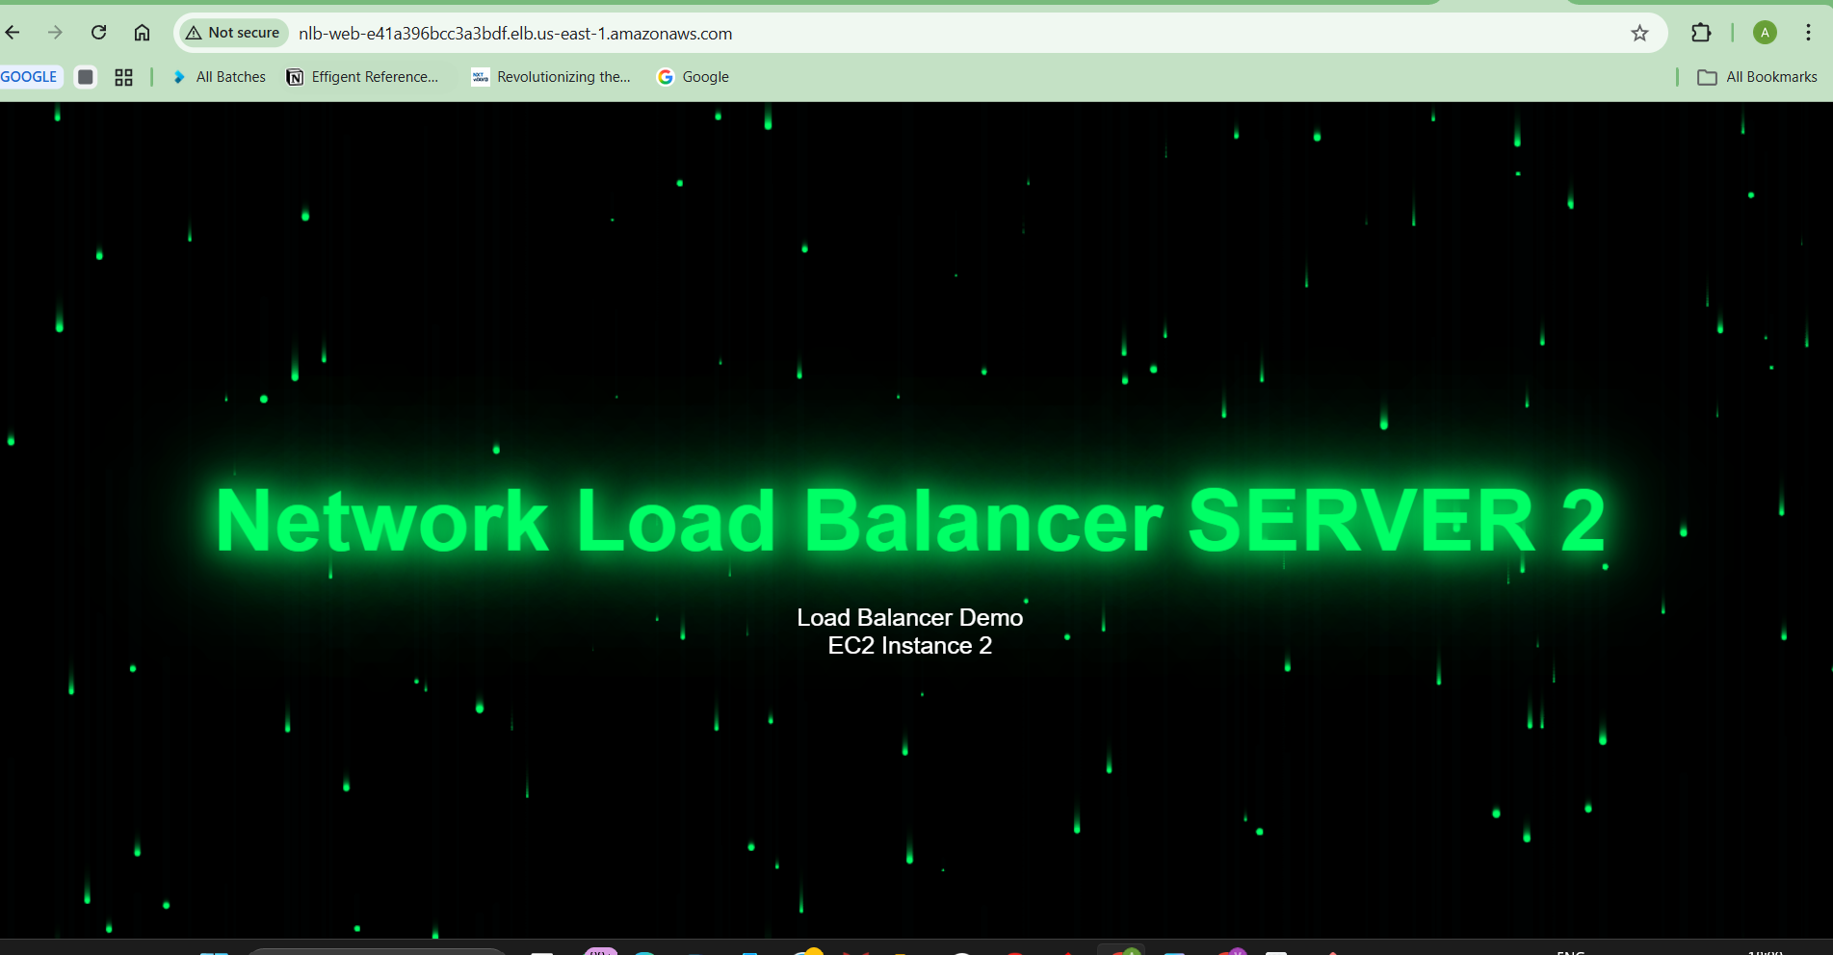
4) Attach SSL to Application Load Balancer
SSL is handled using ACM.
Step 1 — Request Certificate
Go to
AWS Certificate Manager (ACM)
Click
Request Certificate
Enter domain
Example
example.com
www.example.com
Validation
DNS Validation
Step 2 — Validate Domain
Add DNS record in Route53.
Wait until
Status = Issued

Step 3 — Attach to ALB
Go to
EC2 → Load Balancers
Select
ALB-Web
Edit Listener
Add
HTTPS : 443
Choose
ACM Certificate
Forward to
Target Group
Now HTTPS works
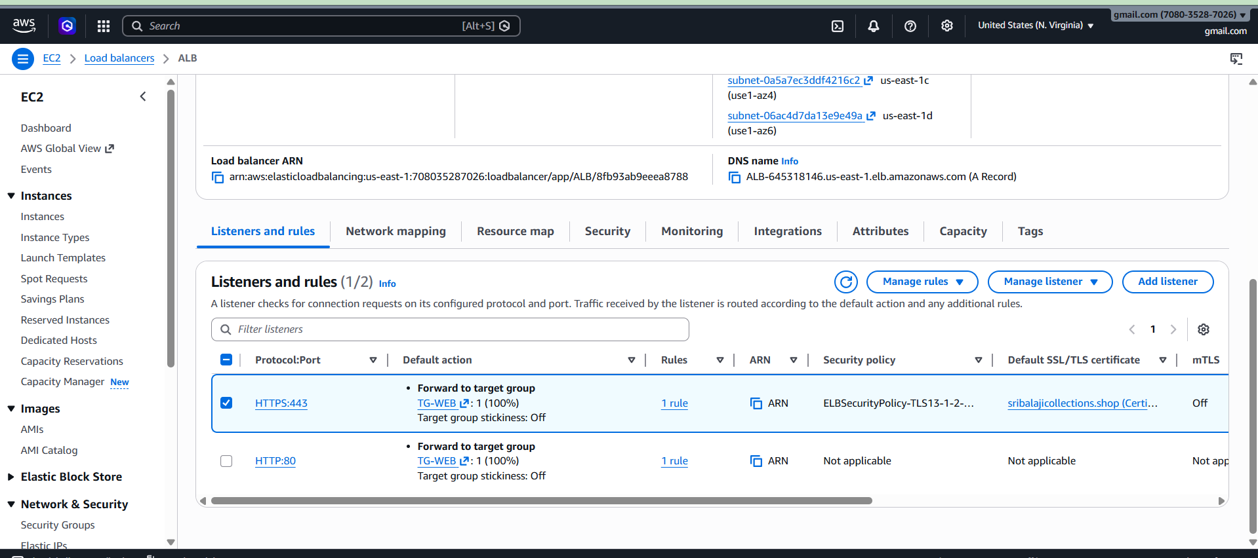

5) Map ALB to Route 53
Go to
Route53
Create Hosted Zone.
Example
example.com

Create Record
Click
Create Record
Type
A Record
Alias
Yes
Alias Target
Select
Application Load Balancer
Example
ALB-Web
Save.

Now domain works.
Example
https://example.com

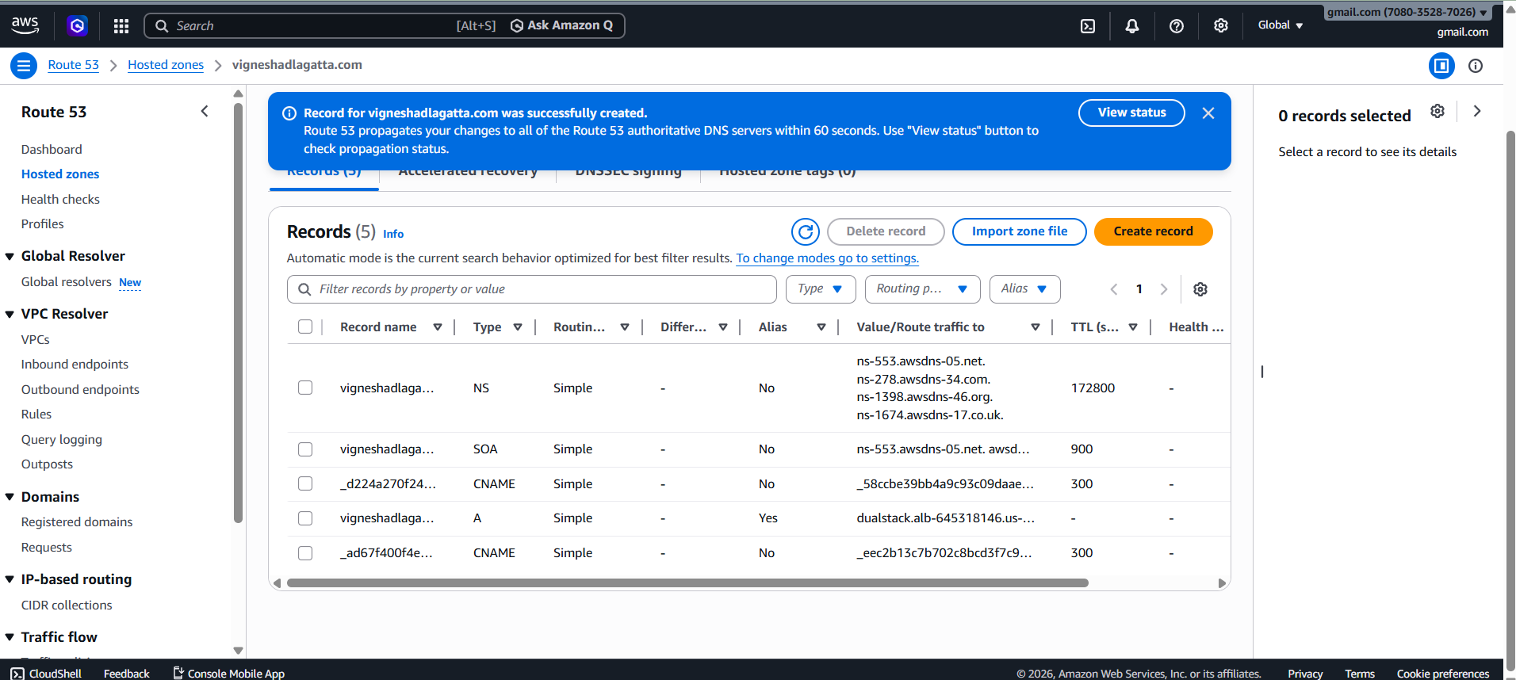

6) Push ALB Logs to S3
Step 1 — Create S3 Bucket
Go to
S3 → Create Bucket
Name
alb-logs-demo
Disable
Block Public Access
Create.

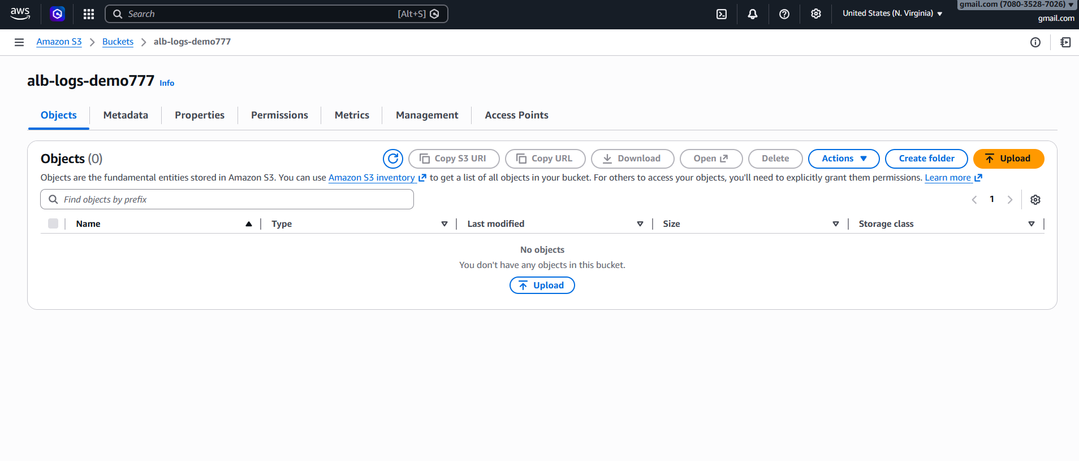

Step 2 — Enable Access Logs
Go to
EC2 → Load Balancer → ALB-Web
Select
Attributes
Edit
Enable
Access Logs
Select bucket
alb-logs-demo
Save.
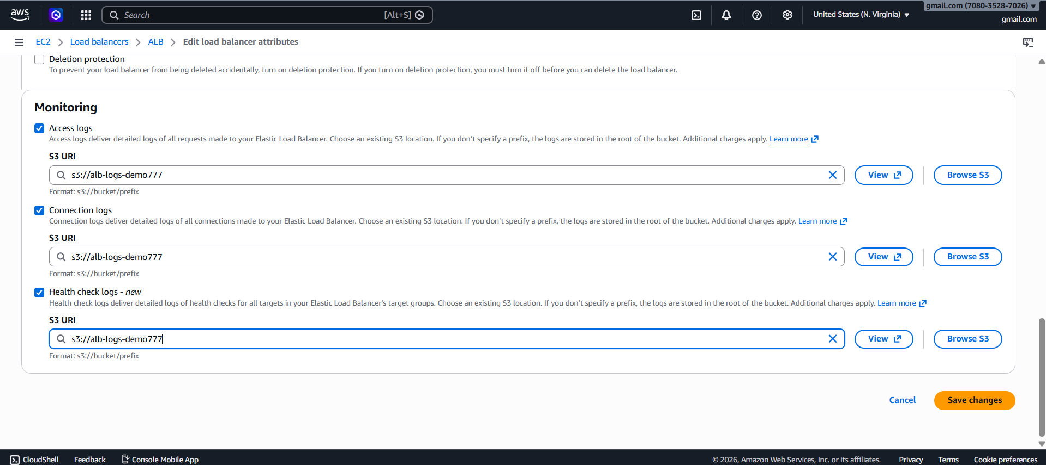

You Need To Add This Policy In Bucket Permission - /* Replace This With Your Bucket Name "Resource": "arn:aws:s3:::alb-logs-demo777/AWSLogs/*" */

{
"Version": "2012-10-17",
"Statement": [
{
"Sid": "AWSLoadBalancerLogsPolicy",
"Effect": "Allow",
"Principal": {
"Service": "logdelivery.elasticloadbalancing.amazonaws.com"
},
"Action": "s3:PutObject",
"Resource": "arn:aws:s3:::alb-logs-demo777/AWSLogs/*"
}
]
}

Step 3 — Check Logs
Go to
S3 → alb-logs-demo
You will see
AWSLogs/
account-id/
elasticloadbalancing/

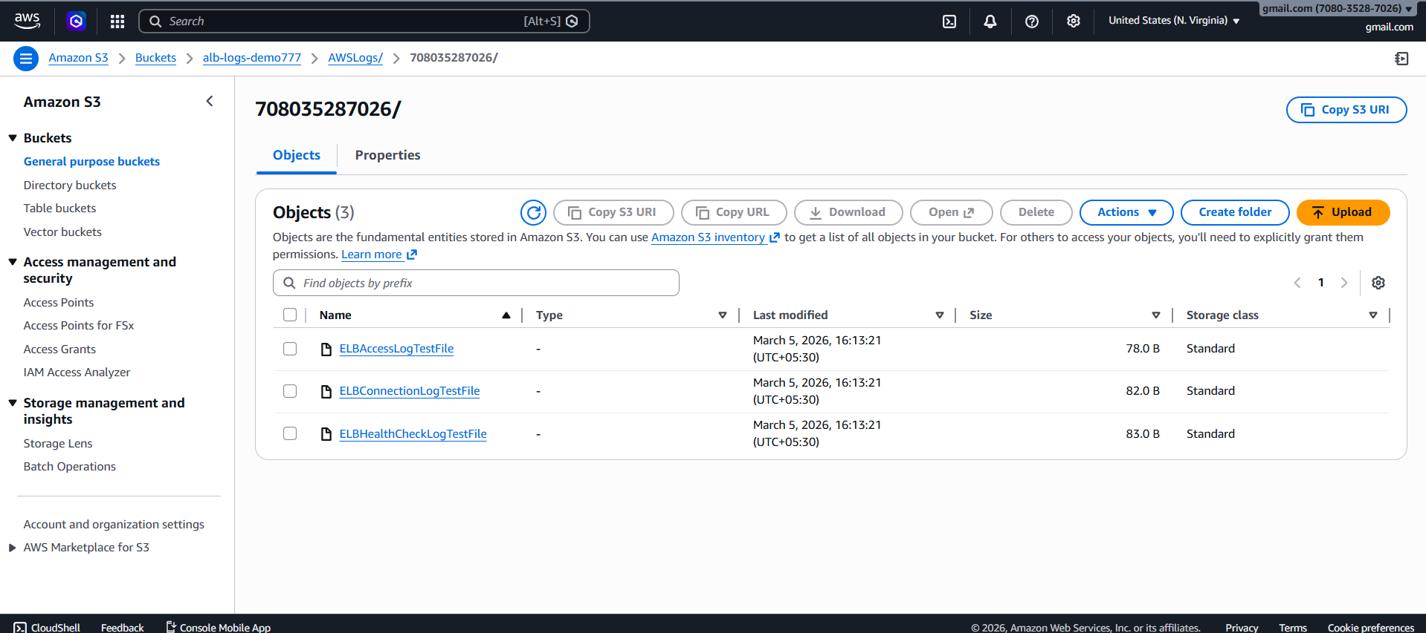
Logs stored successfully

Conclusion:
This Task demonstrates how AWS Load Balancers distribute traffic across multiple EC2 instances to ensure high availability and fault tolerance. It also shows how SSL and DNS can be integrated to provide secure and scalable web application access.

